**Week 3 (Mechanical Engineer):**

I used the previous Fusion model and added wheels to the feet as well as a suspension system. Here is an image of the wheels with suspension system:

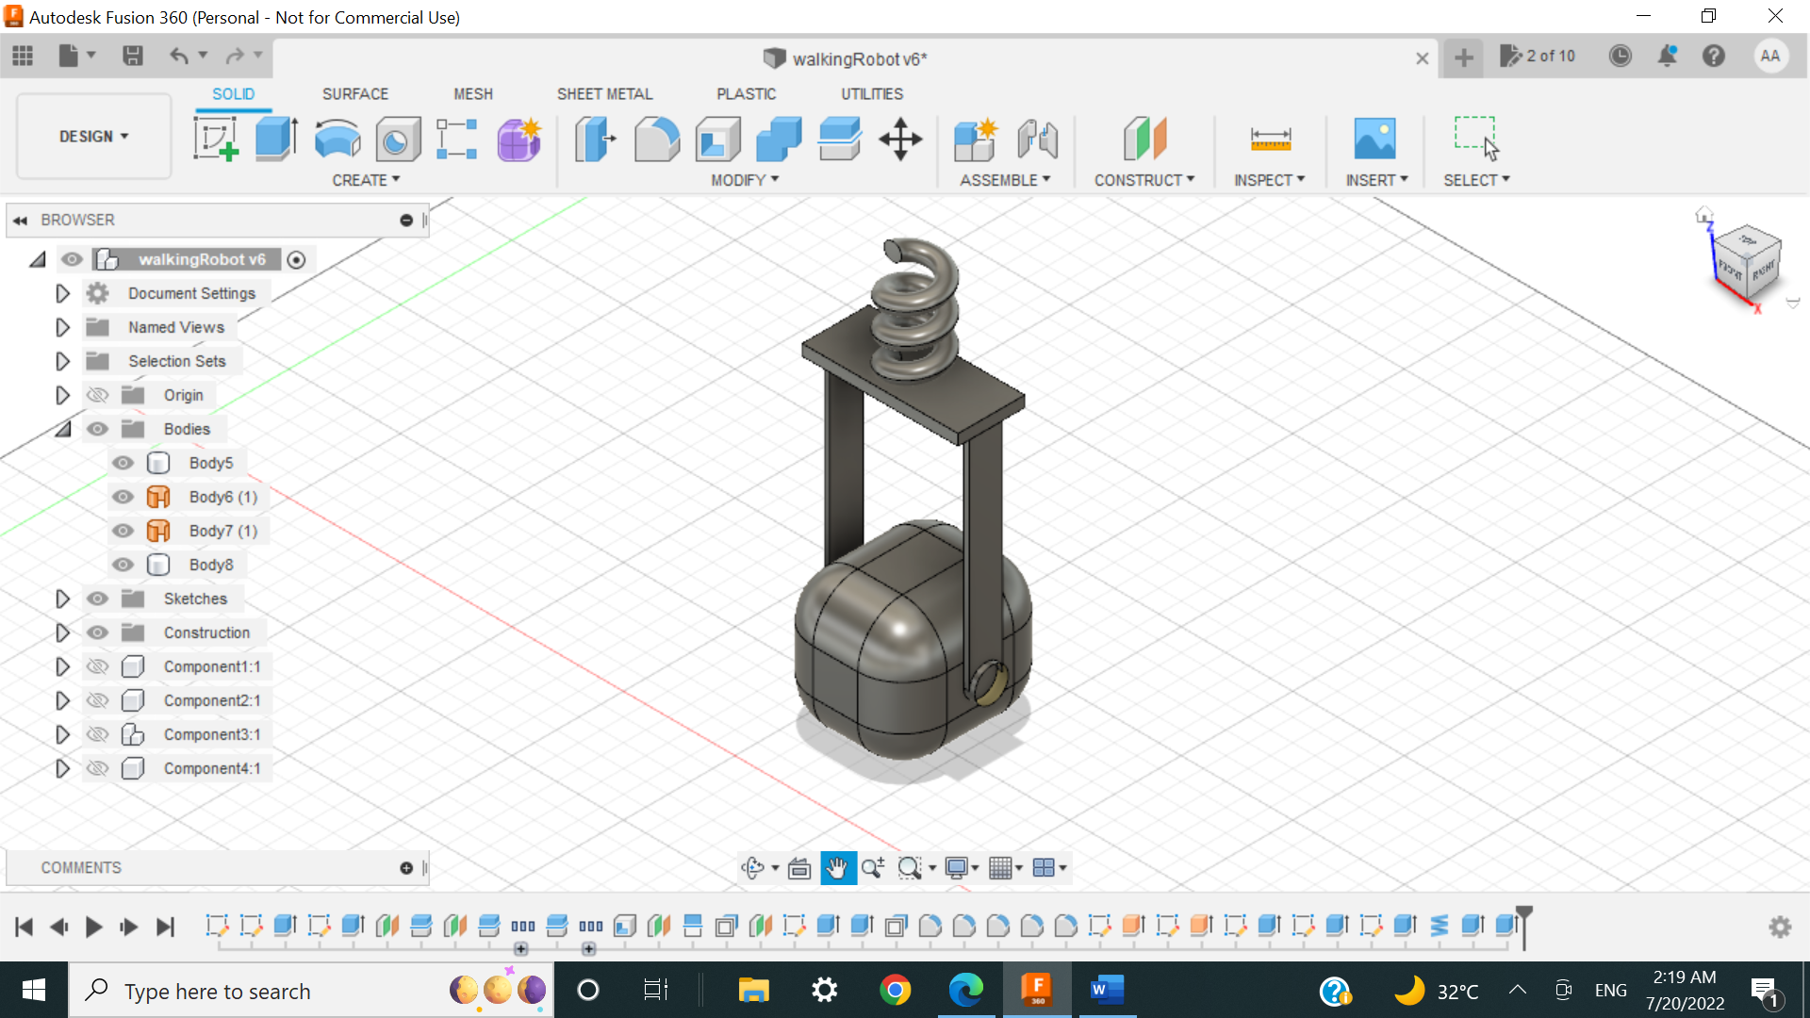

Wheel

Rod

Spring

(Isometric view)

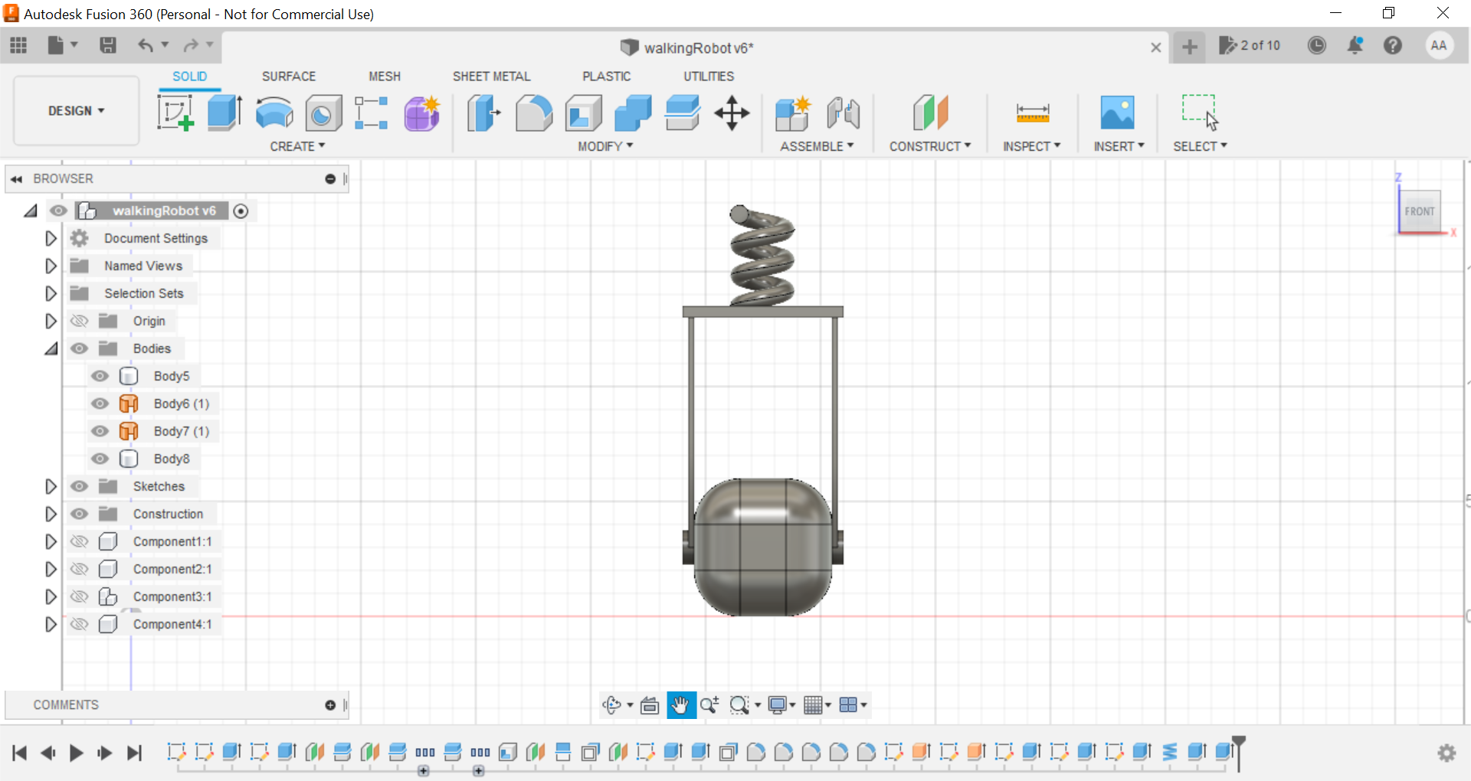

(Front view)

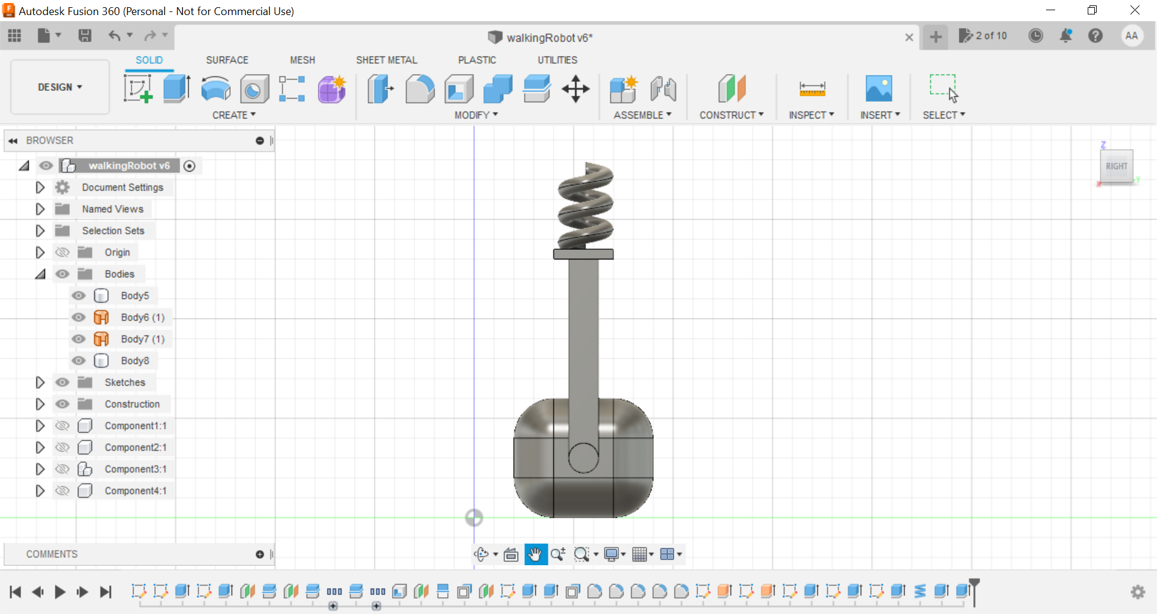

(Side view)

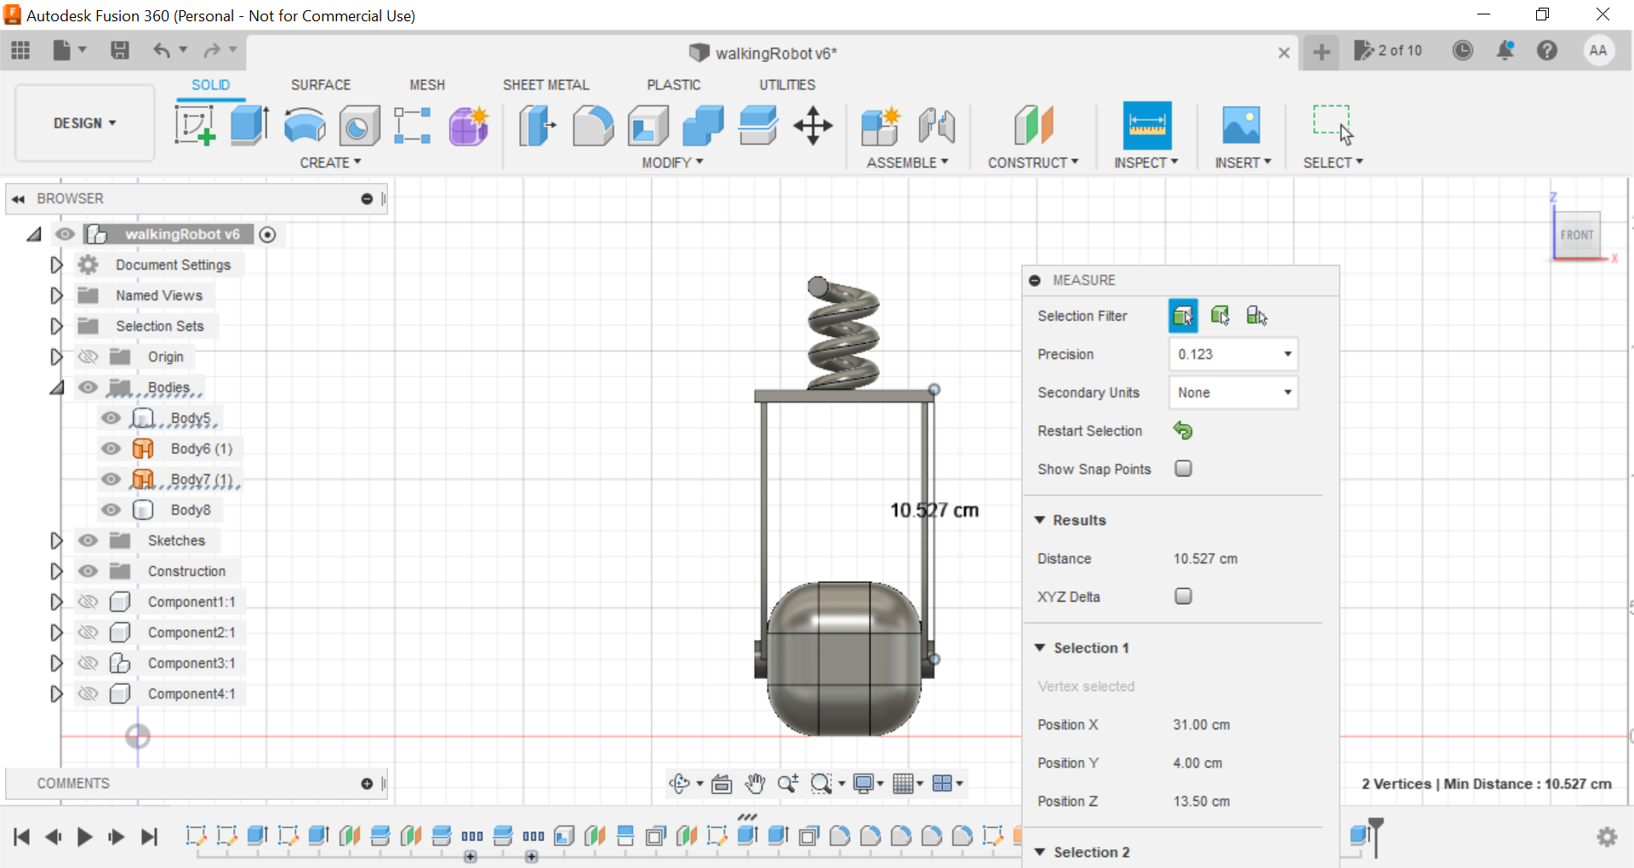

(Rod length measurement with plate)

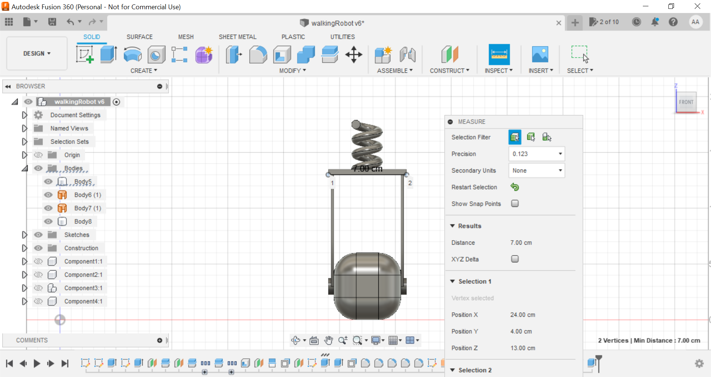

(Plate length measurement)

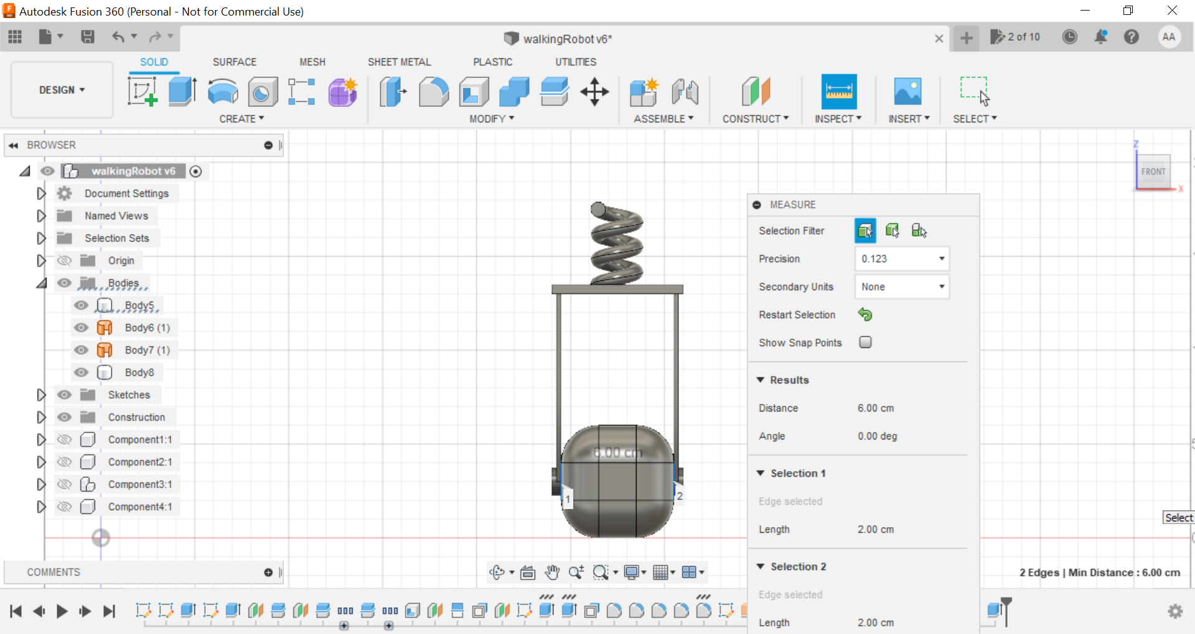

(Wheel diameter)

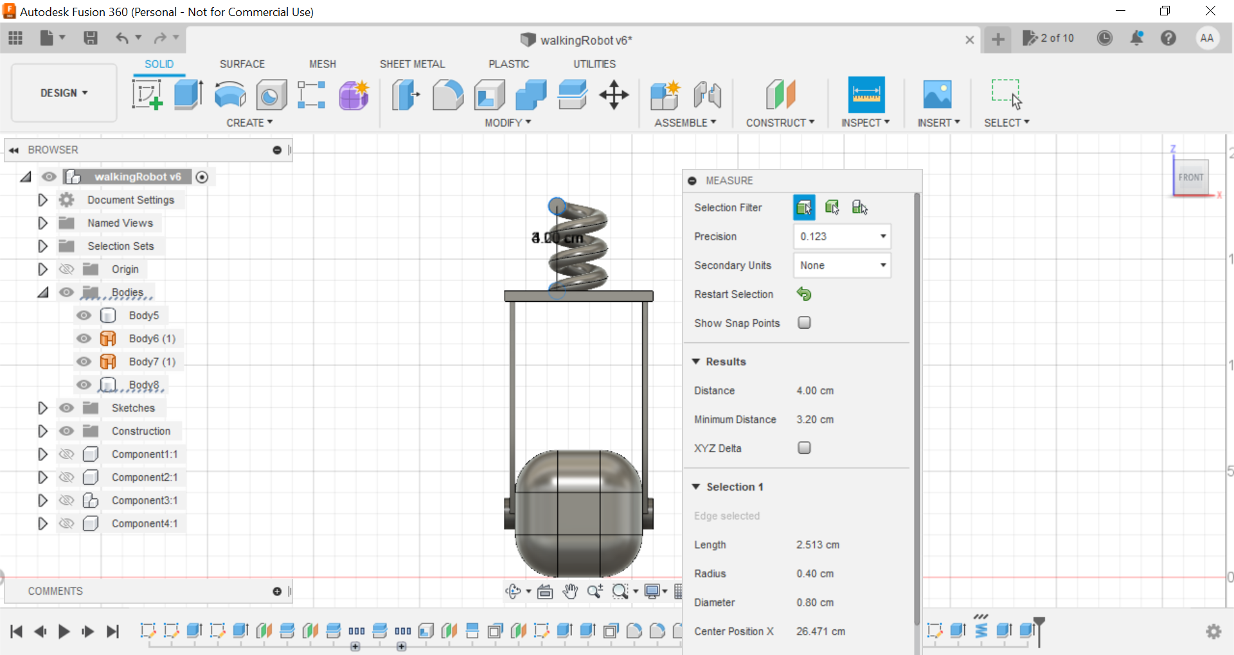

(Spring measurement)

This design is a simple suspension system design, the rod will absorb the vibration of the road and the spring will dampen it, preventing the vibration from transferring to the rest of the robot’s body.

Here is are images of the wheels and suspension system in the robot leg:

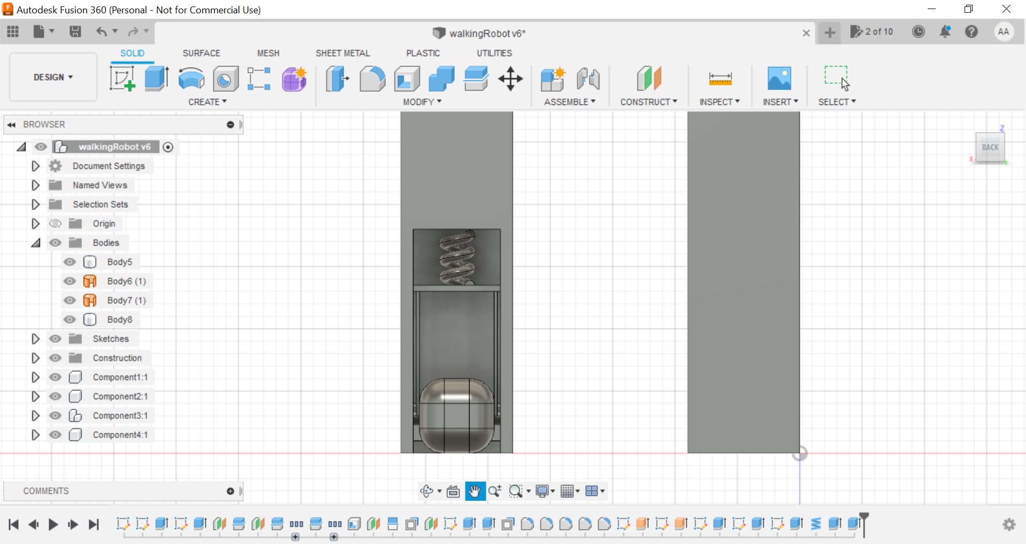

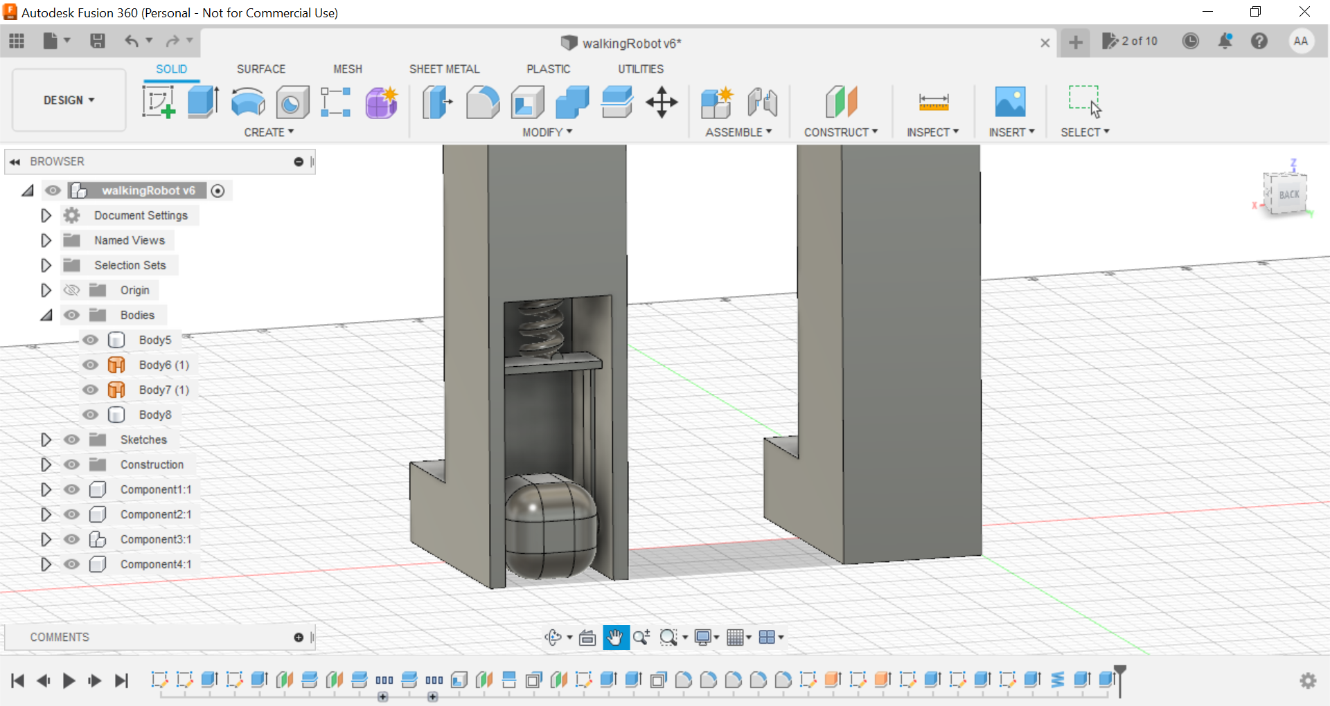

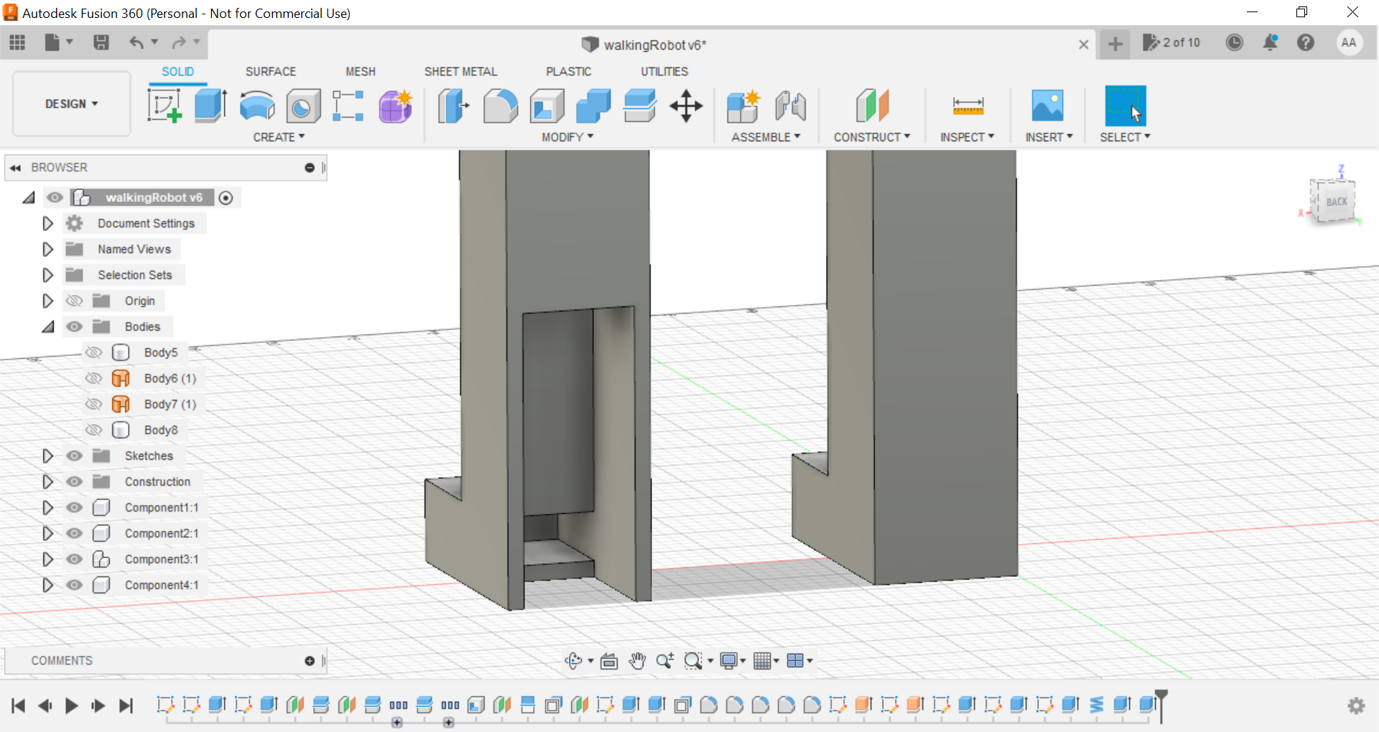

(Robot leg without wheel and suspension system)